September 2026 Friends of the Forest Newsletter
  - Berea College Forestry Outreach Center at the Pinnacles: Homelands of Shawnee and Cherokee Peoples
Tuesday through Saturday 10:00am to 4:00pm, Sunday 12:00 to 4:00pm.
Trails open dawn to dusk, daily.
2047 Big Hill Rd. Berea, KY 40403
859-756-3315
https://forestryoutreach.berea.edu

Upcoming Events
All events at the FOC/Pinnacles unless otherwise noted. Free and open to all. Outdoor activities weather-dependent.
- International Vulture Awareness Day, Sept. 5th, 10:00am-12:00pm
- Cosmic Cafe & Star Party, Sept. 10th, 8:00pm
- Sound Walk on the Stephenson
- Trail, Sept. 12th 6:45am
- Nature R&R at Anglin Falls, Sept. 17th, 5:30pm – email signup required
- Bug Big Day! Sept. 18th
  - Homeschool session: 9:30am-11:00am
  - Documentary & bug viewing: 5:00-7:00pm
- Group Hike at Anglin Falls, Sept. 23rd, 5:30pm – email signup required
- Homeschool Activity, Sept. 24th 10:30am-12:30pm
- Night Hike, Sept. 29th 7:30pm
- Family Activities: see details on p. 2
  - -Sundays at 2:00pm
  - -Sept. 12th & 26th off site
- Recurring Events
- Forest Meditations each Saturday 9:00-10:00am
- *Group Hikes each Saturday 1:00pm except Sept. 12th is 1 mile sensory walk

Celebrating Nature’s Clean Up Crew
Vultures are a bird that can get a bad reputation, labeled as scary, dangerous, dirty, and ugly. The truth is, they are an essential part of global ecosystems: they clean up deceased fauna, reducing the transmission of diseases and parasites.
Kentucky is home to the turkey vulture and black vulture, both of which have fairly stable populations but many vultures around the world are facing declining numbers. Unfortunately, vultures in the U.S. experience human-caused threats like vehicle collisions, lead poisoning, and intentional killing. There are many misunderstandings and myths associated with vultures and their ecological and cultural importance is often overlooked. Join us in learning about these amazing critters on...
International Vulture Awareness Day
at the Pinnacles September 5th, 10:00am-12:00pm
10:30am: vulture monologue by Bob Martin followed by a reading of Victor T. Vulture by Roger & Libby Jones, readings of Vulture View and I Got Barfed on by a Turkey Vulture
-Time for questions and sharing your own writing/poetry
-activities including making vulture vomit slime, vulture sculptures, games, and a community art piece
-trivia of vulture myths & facts
-vulture-themed community art gallery
-information on the Berea Road Ecology citizen science project
...and more!
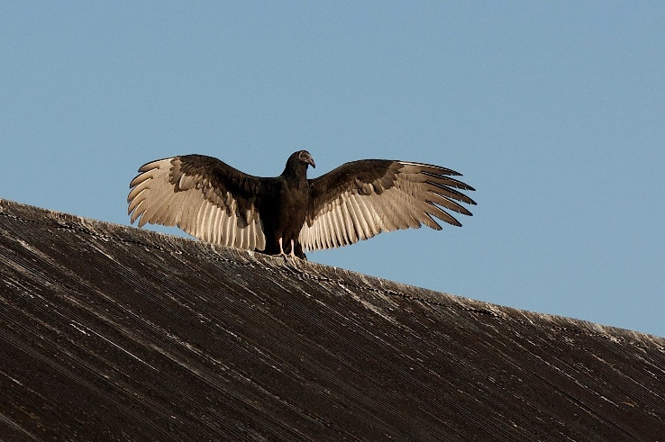

A black vulture warming itself up in the sun

Nature R&R
September 17th at Anglin Falls, meet at the Center at 5:30pm

Email Wendy at warrenw@berea.edu to sign up. We will meet at the Center first.

We live in an age where stressors are all around us--and hope sometimes seems hard to come by. Research is increasingly describing what our bodies need: time together in the natural world we are a part of and opportunities for our bodies to remember this connection. As our stress levels come down, all of our body’s systems function as they should. Join us to experience this for yourself.

Anglin Falls Hike
September 23rd, meet at the Center at 5:30pm
Email Wendy at warrenw@berea.edu to sign up. We will meet at the Center first.
When it’s sunny and hot in the summer, Anglin Falls is a great place to hike. The falls are rain-dependent, so it may or may not be flowing strongly.

Forest Meditations
Saturdays, 9:00am-- meet at the Center
Come join us for Forest Meditations every Saturday at the Forestry Outreach Center. This is an opportunity to connect with ourselves, each other, and the earth. All are welcome.

Cosmic Cafe and Star Party
September 10th, 8:00pm
Cosmic Cafes are casual meetings open to all who are interested in the night sky. If the weather allows, we will observe the night sky through telescopes!

Bug Big Day
September 18th, 5:00-7:00pm
This time of year, the forest is full of insects--especially caterpillars. Come view live native caterpillars up close and see the awesome documentary The Extraordinary Caterpillar.

Night Hike
September 29th, 7:30pm
Join us for the last night hike of the year!
We will do a slow, 1 mile loop to look for nocturnal critters. Please bring a flashlight and be prepared for uneven terrain.

Family Activities
Geared towards elementary ages.*Starred outdoor activities are weather-dependent. RSVP on Facebook for more info and updates.
Sundays, 2:00-3:00pm
Sept. 6th: Ant Antics--Learn about the amazing ant and make your own replica ant colony.
Sept. 13th: Animal Migration--Learn the ‘who’, ‘why’ and ‘where’ of migration and create your own interactive journal.
Sept. 20th: Bug Big Day--Learn about native insects, especially caterpillars!
Sept. 27th: Lightning Bugs--Bring the flickering lights of summer nights inside by
crafting your own glowing firefly.
Whimsical Woods Series at MCPL, 1-3pm
Fairies were said to once roam the old forests. Recreate those magical times by making your own nature-inspired woodland fairy family.
Sept. 12th,: Berea Branch, Community Room
Sept. 26th: Richmond Branch, Room #138
HOMESCHOOL SESSIONS– registration required,
email zagrayk@berea.edu
*Sept. 18th 9:30-11:00am: Bugs!
*Sept. 24th 10:30am-12:30pm: The Lives of Trees

Tree of the Month!
By Michael Mecham
September's tree of the month is Quercus palustris (Pin oak). The pictured tree is ID 5337, and is part of our campus Urban Forest. It sits between the front of Presser Hall and Chestnut Street, and measures 22.1 inches in diameter. Pin oak acorns have characteristic "pin stripes,” which gives the tree its name! Pin oaks are one of few tree trees that does not "self-prune,” and will hold onto dead branches indefinitely. This sometimes gives a perfectly healthy Pin oak tree a sickly look...
Their wood is less sought after than other oak species, but is used for wood pulp and paper. They prefer full sun, are fast growing for oaks, and grow to be between 70-90ft tall!
You can explore all of the trees on campus through our website under “Forest Ecosystem.”

