August 2026 Friends of the Forest Newsletter
  - Berea College Forestry Outreach Center at the Pinnacles: Homelands of Shawnee and Cherokee Peoples
Tuesday through Saturday 10:00am to 4:00pm, Sunday 12:00 to 4:00pm.
Trails open dawn to dusk, daily.
2047 Big Hill Rd. Berea, KY 40403
859-756-3315
https://forestryoutreach.berea.edu

Upcoming Events
All events at the FOC/Pinnacles unless otherwise noted. Free and open to all. Outdoor activities weather-dependent.
Center closed August 18th for student orientation
- Nature R&R/Forest Bathing at Anglin Falls August 5th, 9:30 am *Sign up required*
- Hike at Anglin Falls August 11th and 19th, 5:30pm *Sign up required*
- Cosmic Café & Star Party August 20th, 8:00pm
- Night Hike, August 27th, 8:00pm
- Family Activities:
Geared towards elementary aged kids but all welcome
  - August 2nd: Crafty Caterpillars, 2-3pm
  - August 9th: Eco-Friendly Water Balloons, 2-3pm
  - August 16th: Hidden Habitats Walk, leave at 2:00pm
  - August 30th, Forest Reptiles, 2-3pm
- Recurring Events
  - Forest Meditations each Saturday 9-10am
  - Group Hikes each Saturday 10:00am

A Summer Full of Learning
Kayla, our Education and Outreach Coordinator, is back from a trip to Kenya through her graduate school program, Project Dragonfly. The trip was focused on human-wildlife conflict and how people in Kenya, specifically Maasai pastoralists, have coexisted with wildlife for millennia. The South Rift Association of Land Owners (SORALO) is an organization that blends the Maasai’s place-based, traditional ecological knowledge and conservation science to guide work in their region. Kayla experienced many mind-blowing wildlife sightings and conversations with SORALO and community members. She has returned home with a deeper belief that to take care of the Earth for future generations, we have to turn to indigenous knowledge and community-led conservation. August 9th is the International Day of the World’s Indigenous People. It is a reminder that no matter how near or far we are from them now, we all come from homelands that our ancestors learned from and cared for as the land cared for them. It is our turn to continue our reciprocal relationships with the natural world.
FOC student Alex Patrick has learned a lot during his summer at the Center! He started his own mini fungarium with dehydrated specimen he collected from the forest. Alex has mailed some off (one to Harvard!) for DNA analysis and research. His summer has been full of learning information and techniques taught by FOC ecologist, John, on how to be a better scientist. And Alex helped teach others about fungus as well! He thinks it it’s something that we should all learn about! The best way is to go out and explore yourself, using iNaturalist.org, or by reading and watching videos!
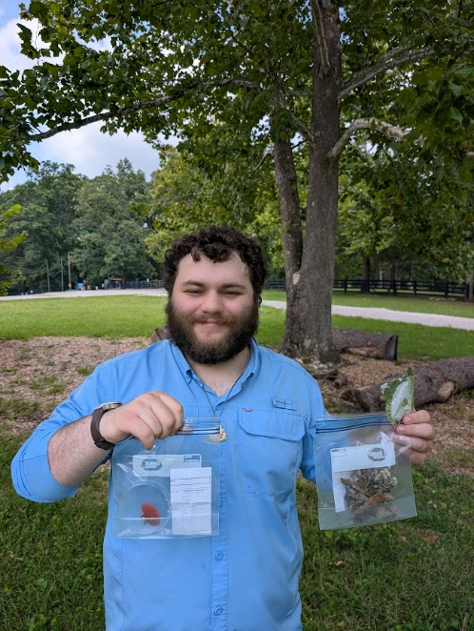
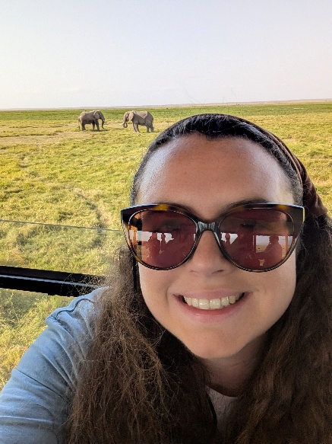

Left: Kayla with elephants (her favorite) in the background
Right: Alex with some of his mushroom specimen

Nature R&R
August 5th, 9:30am at Anglin Falls, meet at the Center

Email Wendy at warrenw@berea.edu to sign up. We will meet at the Center first.

We live in an age where stressors are all around us--and hope sometimes seems hard to come by. Research is increasingly describing what our bodies need: time together in the natural world we are a part of and opportunities for our bodies to remember this connection. As our stress levels come down, all of our body’s systems function as they should. Join us to experience this for yourself.

Anglin Falls Hike
August 11th and 19th, meet at the Center at 5:30pm
Email Wendy at warrenw@berea.edu to sign up. We will meet at the Center first.
When it’s sunny and hot in the summer, Anglin Falls is a great place to hike. The falls are rain-dependent, so it may or may not be flowing strongly.

Forest Meditations
Saturdays, 9:00am-- meet at the Center
Come join us for Forest Meditations every Saturday at the Forestry Outreach Center. This is an opportunity to connect with ourselves, each other, and the earth. All are welcome.

Cosmic Cafes and Star Parties
August 20th & September 10th
Cosmic Cafes are casual meetings open to all who are interested in the night sky. They will be followed by star parties (looking at the night sky) when weather allows.

Family Activities:

Always free and open to all. * Outdoor activities are weather dependent. RSVP on Facebook for more info and updates.
- August 2nd: Crafty Caterpillars, 2:00-3:00pm: Caterpillars are one of the staples of our ecosystem. After you make a caterpillar craft, maybe you can spot some in the forest!
- August 9th: Eco-Friendly Water Balloons, 2:00-3:00pm: Beat the heat with eco-friendly, reusable water balloons made out of crocheted yarn! The fun and coolness without the mess.
- August 16th: Hidden Habitats Walk, leave at 2:00pm: We will go on a slow walk around the lower forest to explore what critters might be living in hidden habitats like holes or under logs.
- August 30th: Forest Reptiles, 2:00-3:00pm: Learn about the snakes, turtles, and lizards we have here in Berea and meet a box turtle in person!

Tree of the Month!
By Lily Gardner
When asked about their favorite tree, the most common pick from this summer’s Urban Forestry team is Quercus Alba (White oak), our tree of the month! The white oak is a keystone species that is native to the eastern and central U.S. As a keystone species, the white oak hosts over 200 species of insects. They also support wildlife by producing acorns, which are a valuable source of food, and create essential habitats through branches and foliage. Historically, white oak has been a reliable material due to its durability, which makes it a popular choice for whiskey barrels. The wood structure contains microscopic tissues called tyloses that “plug” the vascular cells to seal the barrel’s liquid content.
White oaks grow to an average height of 60-100 feet and can grow to a diameter of 3-6 feet. The white oak pictured below (Tree ID 4866) is located behind the Student Craft building and is one of the largest on campus with a diameter of 56.2.You can explore all of the trees on campus through our website under “Forest Ecosystem.”
