# February 2025 Friends of the Forest Newsletter

Berea College Forestry Outreach Center at the Pinnacles: Homelands of Shawnee and Cherokee Peoples

Tuesday through Saturday 10:00am to 4:00pm, Sunday 12:00 to 4:00pm.

Trails open dawn to dusk, daily.

2047 Big Hill Rd. Berea, KY 40403

859-756-3315

<https://forestryoutreach.berea.edu>

## February Events

All events at the FOC/Pinnacles unless otherwise noted. Free and open to all. Outdoor activities weather-dependent.

* Nature Walk/Hike at the Pinnacles: Saturdays at 1:00pm, meet at FOC.
* Forest Meditations 9:00-10:00am every Saturday starting February 15th. Indoors or in the pavilion, depending on weather
* The Great Backyard Bird Count Info Session, February 13th 4:30-5:30pm at the Madison County Public Library Berea Branch Meeting Room
  + The Great Backyard Bird Count is February 14th-17th, learn more at <birdcount.org>
* Family Activities
  + Exploring Animal Tracks, February 23rd 2:00-3:00pm
* Discovery Drawers available each day we are open and returned by 3:30pm

## Social Media

Facebook: [Berea College Forestry Outreach Center](https://www.facebook.com/bereacollegefoc)

Instagram: [@bereacollegefoc](https://www.instagram.com/bereacollegefoc/?hl=en)

iNaturalist: Citizen Science Project – [Biodiversity of the Berea College Forest](https://inaturalist.ca/projects/biodiversity-of-the-berea-college-forest)

[Seek app](https://www.inaturalist.org/pages/seek_app) by iNaturalist, great I.D. tool for kids and families

# Love and Hope in the Forest

Some years it’s hard to remember, but signs of spring start to show themselves in the month of February. Here are a few of the first signs to notice as you spend time outdoors this month:

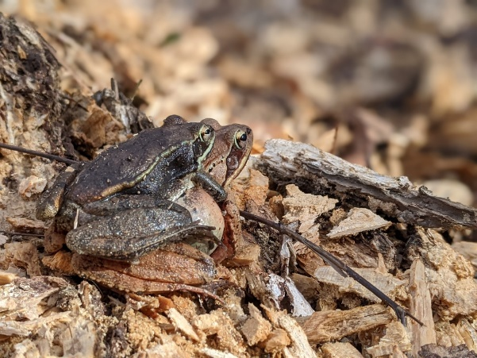Wood frogs begin to call, mate and lay eggs.

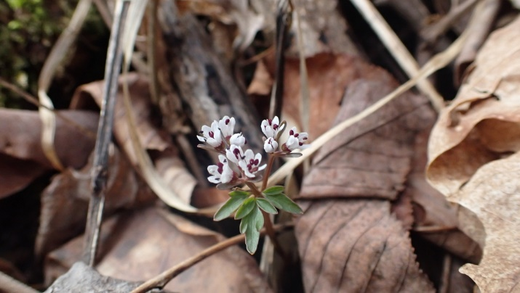Wildflowers like harbinger-of-spring start to bloom .

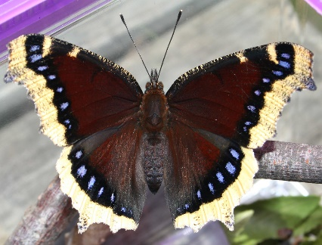Mourning cloack butterflies are one of the earliest to emerge from their chrysalises.

A rabbit standing in grass

Eastern cottontails are more active, ready to find fresh food.

A robin sitting on a branch
Songbirds will start to sing again and you might hear the “peent” of a woodcock!

### A red cardinal bird sitting on a branch

### A brown and tan bird with a long beak sitting on the ground

### Forest Meditations

Saturdays 9:00-10:00am starting February 15th

Come join us for Forest Meditations every Saturday from 9-10am at the Forestry Outreach Center. This is an opportunity to connect with ourselves, each other, and the world. All are welcome. We will meet in the classroom until the weather gets warmer at which time we'll switch to the pavilion. Bring your mats or cushions if you like. Chairs will be provided. We will start with a short introduction to the sit, meditate for about 20 minutes, and then invite you to reflect on your experience in any way you wish. It could be through writing, drawing or quiet contemplation. We would then welcome anyone who would like to share from their experience. We would love to have you linger afterwards for coffee and conversation.

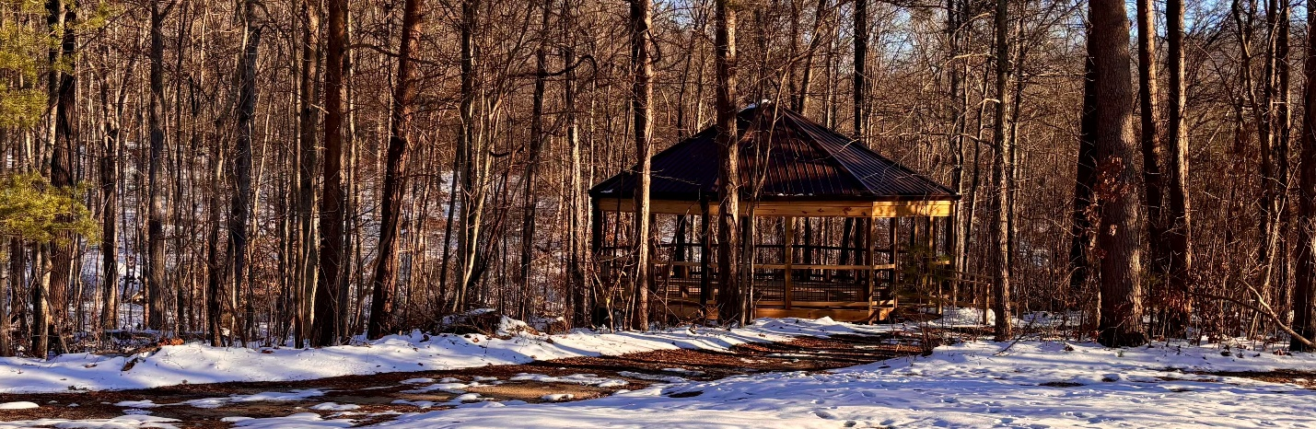

##### “I had always found comfort in the leaves, in their silence. They were like a parchment that holds words of wisdom. Simply holding them in my hand gave me some of the peace a tree possesses. To be like that-to just be-that's the most noble thing of all.” -Silas House, A Parchment of Leaves

### Family Activity: Exploring Animal Tracks

February 23rd 2:00-3:00pm

As winter turns to spring, animals start emerging from their slumbers... and there’s plenty of mud on the ground for them to leave footprints behind! We will learn about how to tell what clues might help you find what critters are scampering about.

### The Great Backyard Bird Count 2025

Learn how to become a citizen scientist and contribute to decades of research about bird populations with just 15 minutes of your time on February 14th-17th. Great for all ages and skill levels to connect with birds and nature. Learn more on <birdcount.org>.

Participation Info Session with Forestry Outreach Center staff

WHEN: February 13th, 4:30-5:30pm

WHERE: Meeting Romo at the Berea Branch of the Madison County Public Library

#### 