# September 2024 Friends of the Forest Newsletter

Berea College Forestry Outreach Center at the Pinnacles: Homelands of Shawnee and Cherokee Peoples

Tuesday through Saturday 10:00am to 4:00pm, Sunday 12:00 to 4:00pm.

Trails open dawn to dusk, daily.

2047 Big Hill Rd. Berea, KY 40403

859-756-3315

<https://forestryoutreach.berea.edu>

## September Events

All events at the FOC/Pinnacles unless otherwise noted. Free and open to all. Outdoor activities weather-dependent.

* Nature Walk/Hike at the Pinnacles: Saturdays. Time changes to 1:00pm for the school year. Meet at the FOC. Student Shuttle leaves Alumni Circle at 12:45pm and returns at 3:30pm.
* Equinox Sunset Hike: September 22nd, leave at 6:00pm
* Nature R&R
  + September 4th, 5:30-7:30pm at Brushy Fork
  + September 26th, 5:30-7:30pm at Anglin Falls
  + RSVP on Eventbrite, info on page 8
* Family Activities
  + September 15th: Fairy House Building 1:30-3:00pm
  + September 22nd: Autumnal Equinox Party! 4:00-6:00pm
  + Discovery Drawers available each day we are open and returned by 3:30pm

## Social Media

Facebook: [Berea College Forestry Outreach Center](https://www.facebook.com/bereacollegefoc)

Instagram: [@bereacollegefoc](https://www.instagram.com/bereacollegefoc/?hl=en)

iNaturalist: Citizen Science Project – [Biodiversity of the Berea College Forest](https://inaturalist.ca/projects/biodiversity-of-the-berea-college-forest)

[Seek app](https://www.inaturalist.org/pages/seek_app) by iNaturalist, great I.D. tool for kids and families

## Spotlight on Summer Student Experiences

Check out these snapshots of some of the amazing, wide-ranging experiences the Forestry Department’s student workers had this summer! We now have these impactful offerings to share...

### Edie Jo Wakin

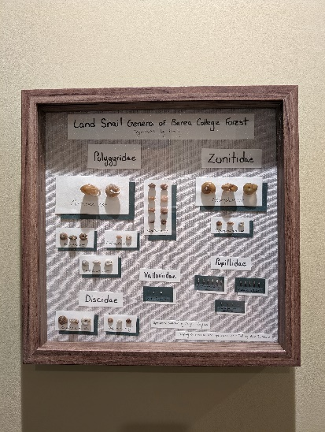Edie Jo completed an internship where they designed and implemented a biological survey of land snails in the Berea College Forest. A display of a sample of snail species can be viewed in the Center!

## Claire Mast

Claire developed self-guided family activities that can be checked out from the FOC. She also supported in various kid’s activities, including co-leading our first summer camp, “Forest Superheroes!”

A person reading a book to a group of children



### Abigail Kingston

Abigail worked over the summer term to foster her plant nursery that contains tree saplings and river cane sprouted from seed! She hopes to contribute to cane restoration and hold a plant giveaway this fall.

A group of small plants in plastic cups



### Utsa Seth

If you visit the FOC you’ll see the friendly face of a crocheted jumping spider! Utsa is working towards a collection of “creepy”-turned-cute critters to make them more approachable to kids.

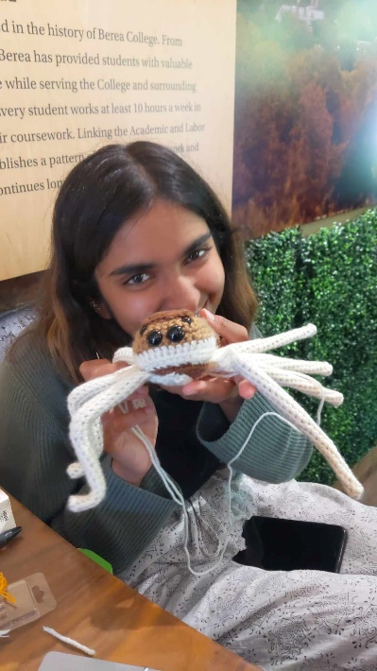

### Abegail Blakey

Abegail studied the geology at the Pinnacles to make educational signage. Look out for them on the trails later this year!

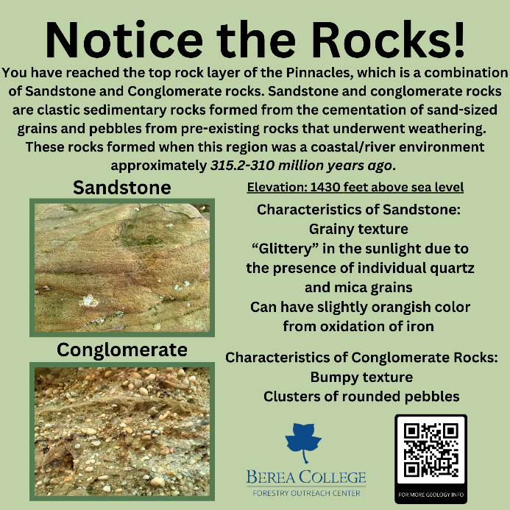

### Ivory Riley

Ivory is working on a fiber art piece that shows Berea’s rock and soil layers. She also helped with kid’s activities and taught us how to make paint from dirt to create with Earth tones-literally!

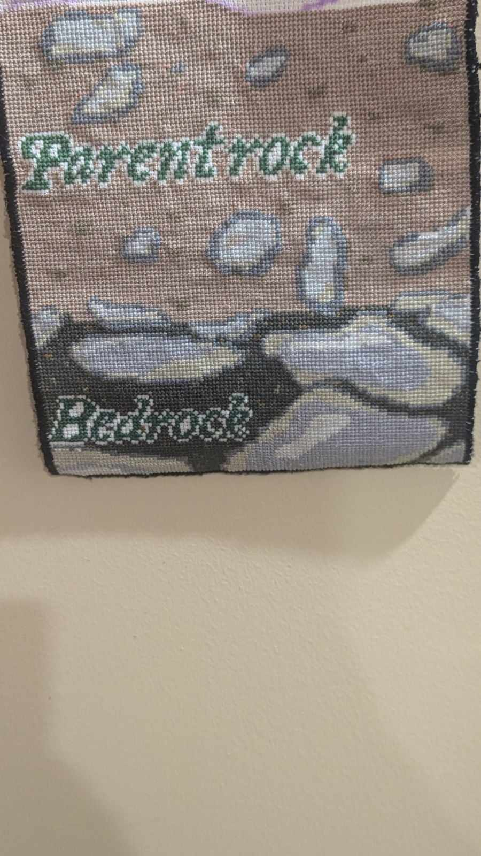

## Some of our students reached far and wide this summer…

### Senna Jenkins

Senna interned on Alderspring Ranch in Idaho, monitoring and herding cattle on horseback. She improved her horsemanship and learned about regenerative grazing, low-stress stockmanship, cattle herd dynamics, and wildlife of the Pahsimeroi Valley.

A person riding a horse



### Vanessa Carroll

Vanessa had the chance to spend 11 weeks in Costa Rica studying tropical ecology, conservation biology, and marine endangered species along with visiting an abundance of national parks.

A person standing on a log in front of a waterfall



### Reuben Hicks

Reuben helped train horses at Interequus in Germany. He got to learn natural horsemanship from Denise Heinlein, a Monty Roberts Master Instructor. This experience furthered his skills while on his journey to become an instructor, himself.

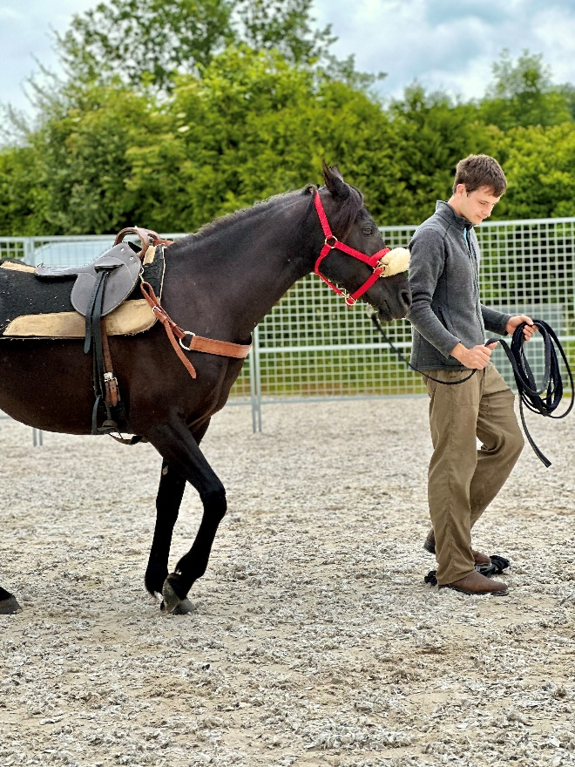

### Kya Norman

Kya worked with the Kentucky Correctional Psychiatric Center as a forensic behavioral health intern and observed the intricate relationship between policy development and mental health within the justice system.

### Zeke Williams

Zeke assisted in archaeological studies, excavating a habitation site for Neanderthals in a cave in southern Spain.

## Farm and Forest Festival November 2nd 2024

Draft Barn Open House: 10:00am to 12:00pm, 140 Short Line Pike Berea, KY 40403

Festivities and Demos: 12:00 to 3:00pm, The Pinnacles 2047 Big Hill Rd.

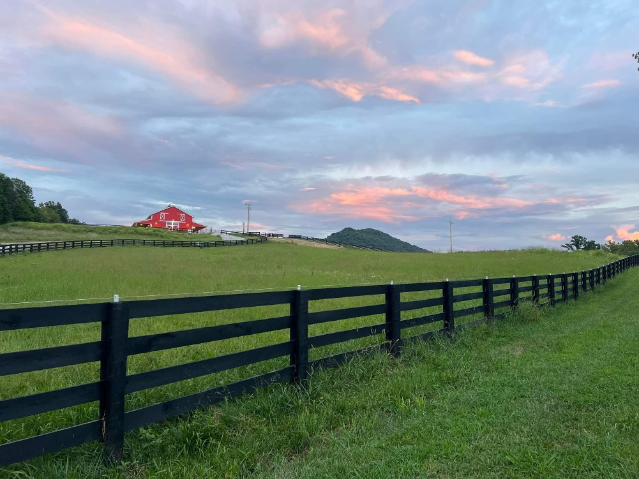

## Nature R&R / Forest Bathing

Wednesdays: start out each month by relaxing and restoring mind, body, and spirit with Nature R&R. Then, transition gently out of the month each last Thursday. Nature Relaxation and Restoration/Forest Bathing is a 2 hour, slow-paced, restorative forest experience. Please bring a portable chair or something to sit on, dress for the weather and wear walking shoes. We hope you’ll join us! Weather dependent, RSVP for updates.

* September 4th, 5:30-7:30pm at Brushy Fork
* September 26th, 5:30-7:30pm at Anglin Falls

[Please RSVP for a FREE spot and find directions on Eventbrite](https://www.eventbrite.com/o/berea-college-forestry-outreach-center-64953059843)!

## September 22nd is the Autumnal Equinox! Sunset Hike:

Meet at FOC, leave at 6:00pm.

We will hike up to the Bluegrass Overlook and enjoy the sunset! The hike is just over a mile one way but is uphill and steep in spots. Please bring a water bottle and dress for the weather and terrain! Bring a light for the hike down.

## Family Activities

Free and open to all. Outdoor activities are weather-dependent. RSVP on [Facebook](https://www.facebook.com/bereacollegefoc) to follow any updates.

* Fairy House Building, September 15th 1:30 to 3:00pm. We’ll use natural and compostable materials to build houses for our forest fairy friends before autumn comes! Materials will be provided, but feel free to bring along any materials you find that you’d like to use or share. We can also use paper towel rolls, fruit rinds, and other household items that will return to the earth.
* Autumnal Equinox Party! September 22nd, 4:00 to 6:00pm. We will celebrate the changing of the seasons with autumnal snacks, books, and crafts! A sunset hike will follow at 6:00pm for those who’d like to join.